Experiment 8

Name:Voleti Ravi

RegNo:15BCE0082

1)Verify the RS, D, JK and T flip flops.

**AIM:**

To verify the RS,D,JK and T flipflops.

**DIAGRAMS:**

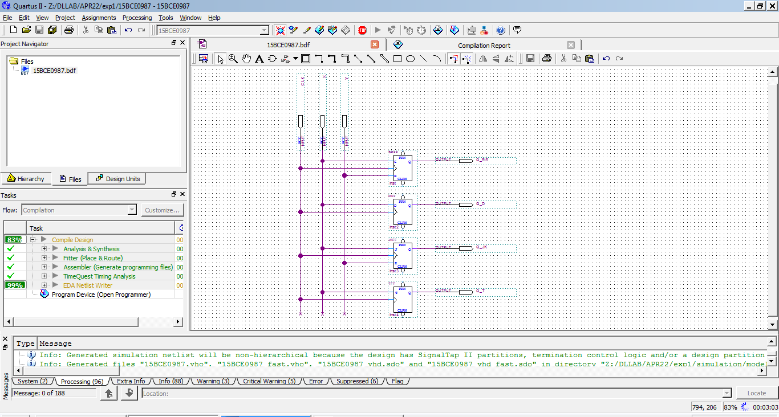

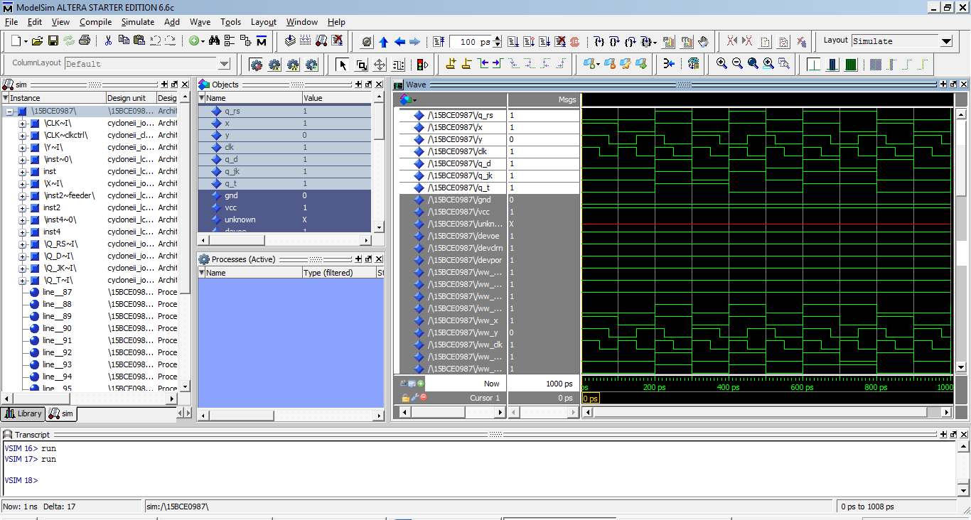

2) Design and implement three bit synchronous binary up-counter.

**AIM:**

To design and Implement a 3-bit synchronous binary up-counter.

**TRUTH TABLE:**

|  |  |  |  |  |  |  |  |  |
| --- | --- | --- | --- | --- | --- | --- | --- | --- |
| **PS** | | | **NS** | | | **O/P FN** | | |
| A | **B** | **C** | **A** | **B** | **C** | **TA** | **TB** | **TC** |
| **0** | **0** | **0** | **0** | **0** | **1** | **0** | **0** | **1** |
| **0** | **0** | **1** | **0** | **1** | **0** | **0** | **1** | **1** |
| **0** | **1** | **0** | **0** | **1** | **1** | **0** | **0** | **1** |
| **0** | **1** | **1** | **1** | **0** | **0** | **1** | **1** | **1** |
| **1** | **0** | **0** | **1** | **0** | **1** | **0** | **0** | **1** |
| **1** | **0** | **1** | **1** | **1** | **0** | **0** | **1** | **1** |
| **1** | **1** | **0** | **1** | **1** | **1** | **0** | **0** | **1** |
| **1** | **1** | **1** | **0** | **0** | **0** | **1** | **1** | **1** |

**EQUATIONS:**

TA=A’BC+ABC=BC

TB=C

TC=1

**DIAGRAMS:**

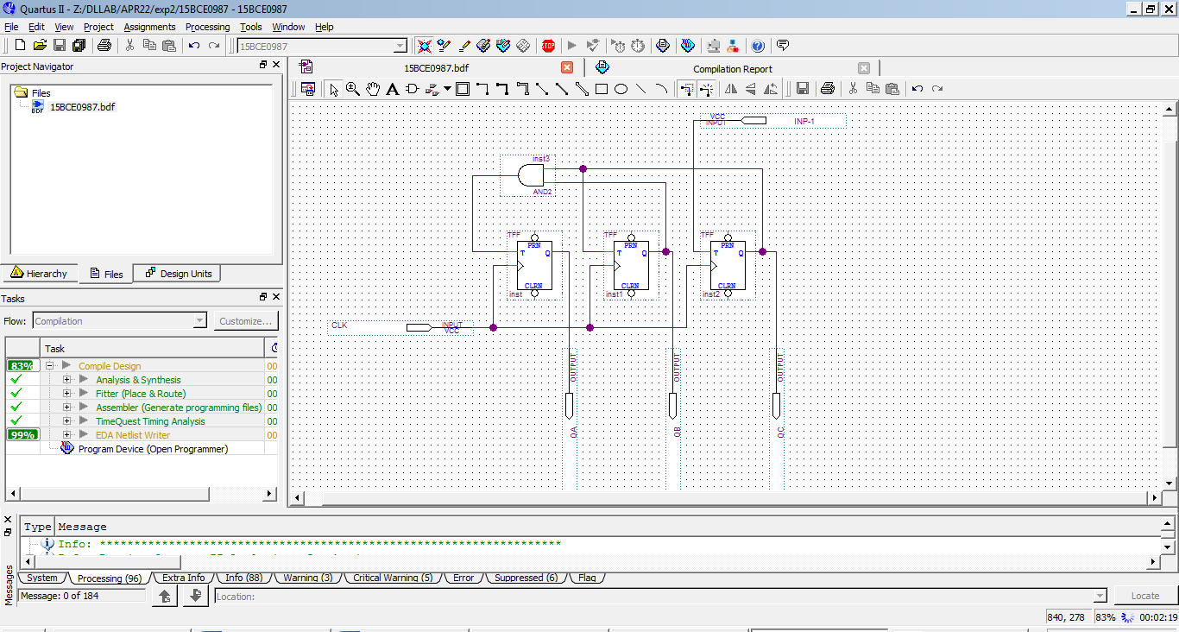

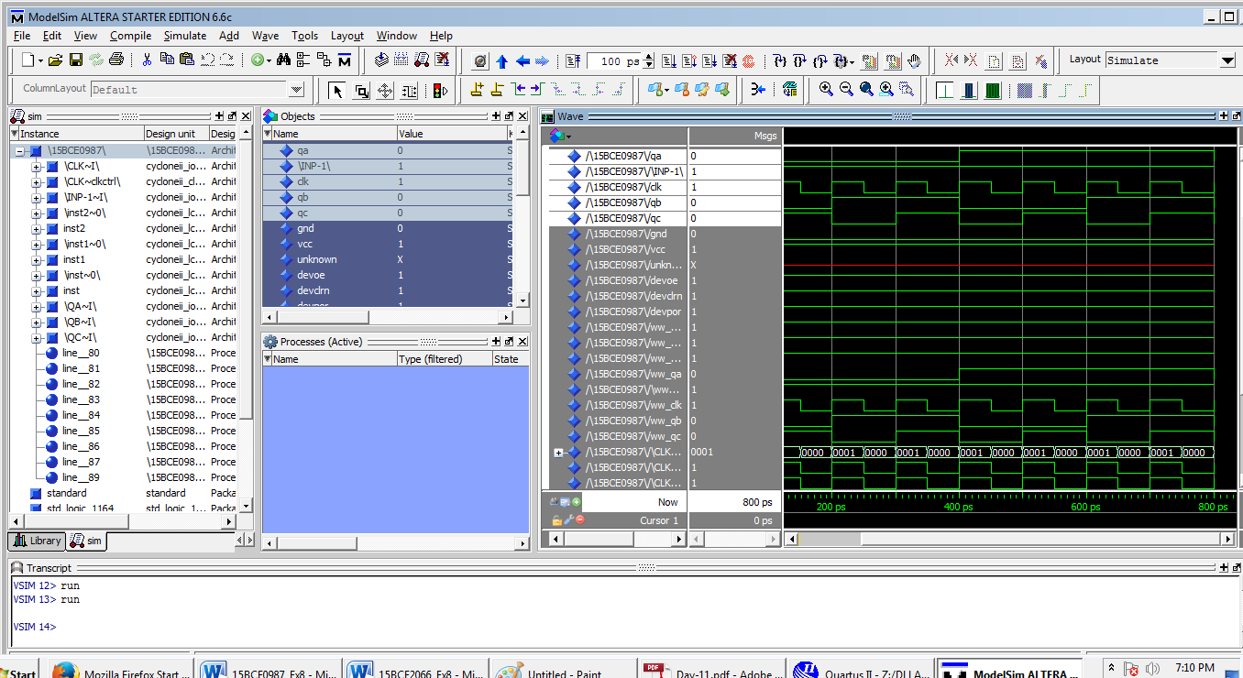

**3)**

